Quiz 2: Force and Circular Motion

- If an non-zero net force is acting on an object, the object must be -
  - moving at a constant velocity.
  - accelerating.
  - moving with increasing speed.
  - at rest.

- A 2000 kg car is traveling westward at a constant speed of 4 m/s. What is the net force acting on the car?
  - 0 N
  - 4 N
  - 2000 N
  - 8000 N

- You are driving a classic sports car when a moose runs across the road. To stop in the shortest distance, you should -
  - Do nothing, and allow the car to come to a stop on its own by hitting the moose.
  - Brake as hard as possible without skidding.
  - Slam on the brakes, causing the car to skid.
  - Press harder on the gas, causing the car to accelerate forward.

- A dump-truck is driving on the highway with a load of sand. The engine exerts a constant force on the truck, causing the truck to accelerate at a constant rate. There is a hole in the bottom of the truck, through which sand is leaking. If the engine's force remains constant, the acceleration of the truck will -
  - remain constant, because the force is constant.
  - Increase, because the mass has decreased.
  - Decrease, because less force is required to accelerate the truck.
  - It cannot be determined without knowing the mass of the truck.

- A man weighs 900N on earth. What would he weigh on a planet that is twice the mass and twice the radius of earth?
  - 225 N
  - 450 N
  - 900 N
  - 1800 N

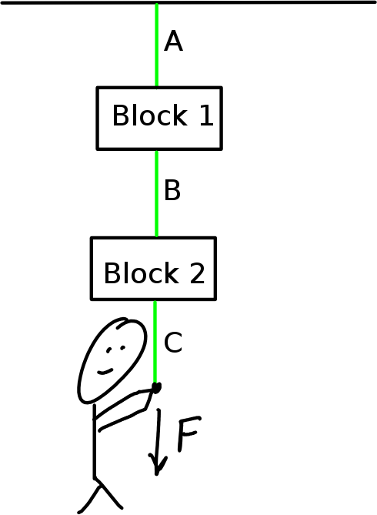
- Block 1 is hung from the ceiling by a a piece of fishing line, A. An identical piece of fishing line, B, is attached to the bottom of the block, and a second, identical block, 2, is hung from the bottom of Block 1. A third piece of fishing line, C, is then attached to the bottom of Block 2. If a person begins to pull on the bottom piece of fishing line, which piece of fishing line is most likely to break first?
  - A
  - B
  - C
  - There is an equal chance of any of them breaking.

- In the movie Interstellar, The Endurance is a spaceship designed to spin to create an apparent gravitational force. The ship has a radius of 32 meters. How fast would the outside of the ship have to spin in order to simulate a gravity equal to Earth?
  - 12.528 m/s
  - 17.718 m/s
  - 156.96 m/s
  - 313.92 m/s

- An 800 N horizontal force is applied to a 20 kg block at rest on a horizontal surface, where m_{s} = 0.6 and m_{s} = 0.4. What is the magnitude of the force of friction on the block just before it begins to move?
  - 800 N
  - 420 N
  - 160 N
  - 24 N

In each of the following questions two answers is true. Choose the TWO answers that best answer the question.
- A large truck collides with a bicycle. Compared to the force the truck puts on the bicycle, the force the bicycle puts on the truck is - (CHOOSE TWO)
  - smaller in magnitude
  - greater in magnitude
  - equal in magnitude
  - in the same direction
  - in the opposite direction.

- An object is in equilibrium. This means the object could be -
  - at rest
  - moving with a constant velocity.
  - accelerating along a linear path.
  - Moving with a constant speed in a circle.

Modern cars use antilock brakes to help solve this problem, but classic cars did not have this technology.

